Meherbani Workflow

# Users based (Expands with time and search)

1. New User
2. Registration
3. Verification
4. Authenticate
5. Login
6. Existing User
7. Login
8. Authenticate
9. Looking for Charity
10. Post Ad(s)
11. Searching
12. Request charity
13. Need Help
14. Submit donation
15. Post donation Ad(s)
16. Searching
17. Respond to Charity Ad(s)
18. Need Help
19. Outside visitor
20. Visit Website (Mobile App Not Accessible without login)
21. Searching
22. Can Visit charity and donation Ad(s).
23. Only View Public information (Sign in is required to see All).
24. Contact Module
25. Ad(s) Posting Module

# 1 - New user

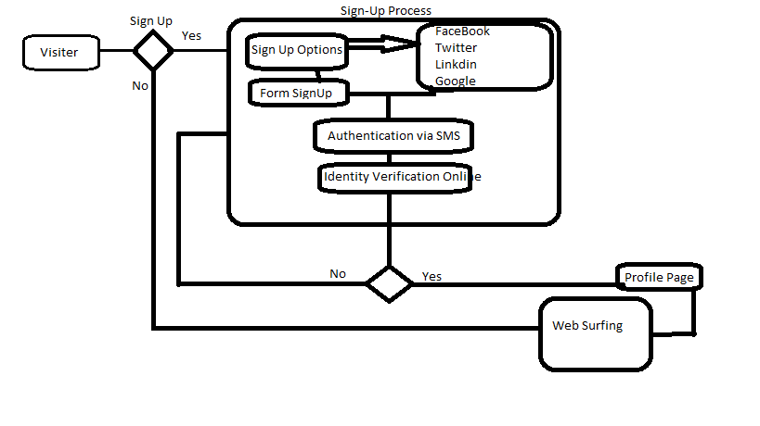

# 2 - Existing user

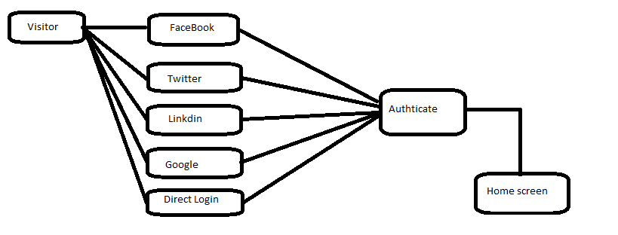

# 3 – Looking for charity

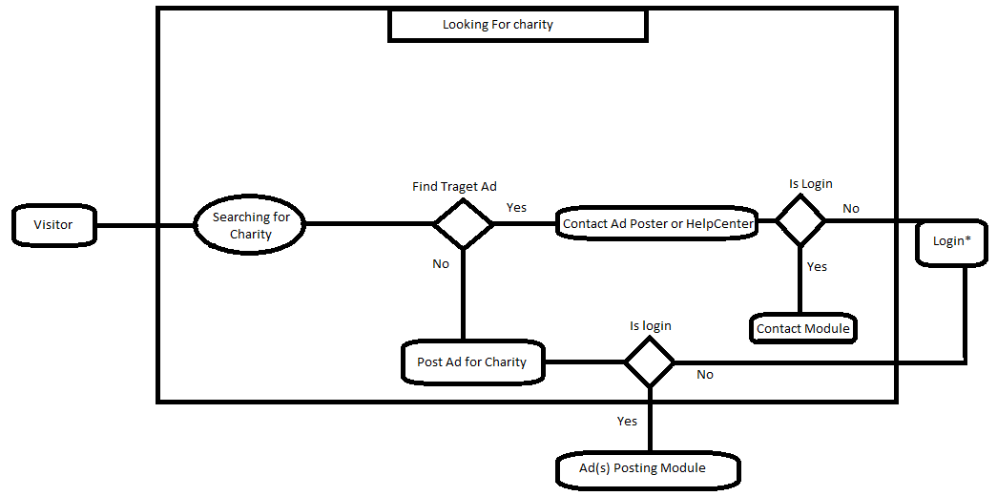

# 4 – Submit donation

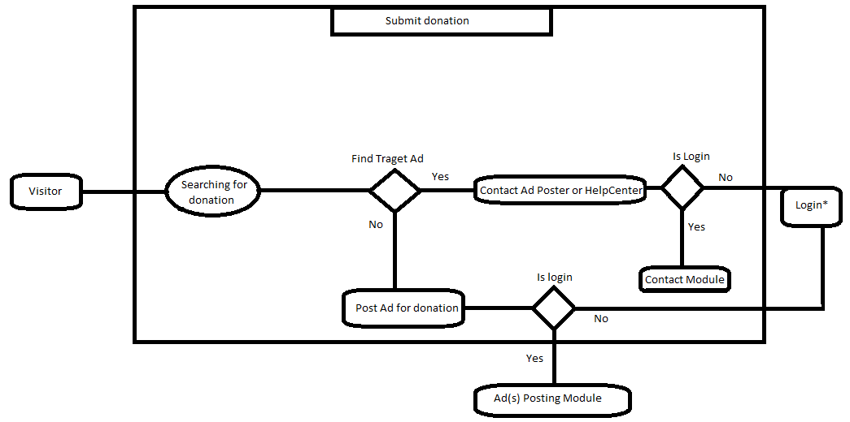

# 5 – Outside visitor

Points Mentioned above

# 6 – Contact Module

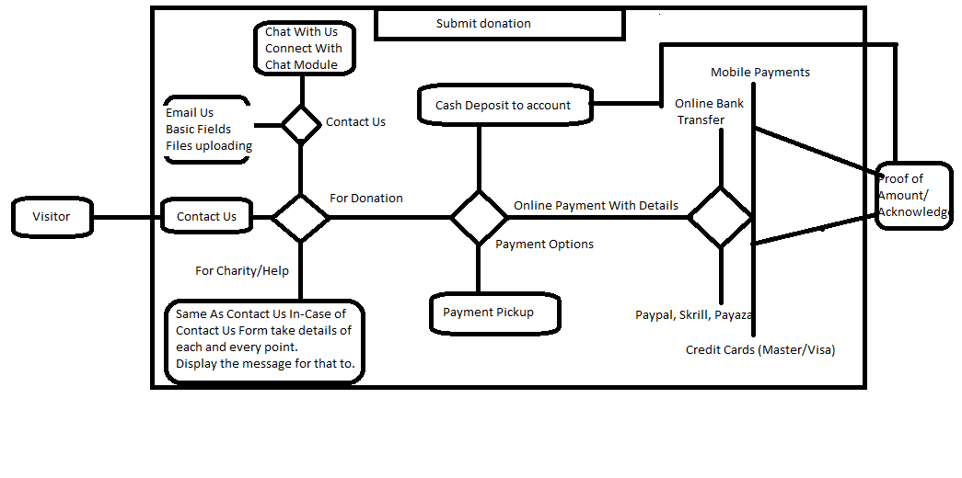

# 7 – Ad(s) Posting Module

